Human Resources: COBRA General Notice + QEN

**Objective/Purpose/ Why:**

* All full-time employees are eligible for benefits, the first of the month after DOH. They MUST be notified that, upon loss of coverage, they are eligible to continue the same benefits, at full cost to them.

**Outcome:**

* The General Notice informs the Employee of their right to COBRA continuation coverage, which is a temporary extension of coverage under the Plan.
* The Qualifying Event Notice is used when an employee’s coverage is terminated from the system. Employee is notified that they have an option to continue same coverage at full cost to them (with the company’s contribution)

**Subject Matter Expert:**

* The Plan administrator must allow you access to create your login credentials or contact HR Director or HR Generalist(s).

COBRA: General Notice: Beginning of Employment

**Process:**

1. Login to UnitedHealthcare

* Log into the COBRA website at: <https://www.uhcservices.com>
* Hit “Go”

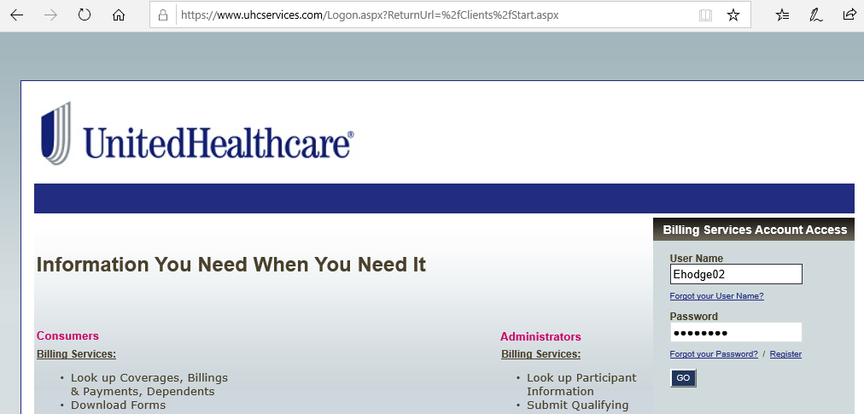

2. Qualifying Event Notification

* Select “Billing Services” from the top navigator.
* Click on “General Notice” on the left side of the screen.
* Enter applicable information and click “Submit”

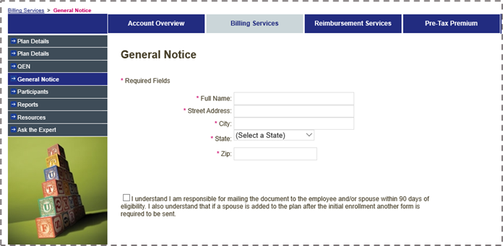

3. Print, Save, and Send

* Print the document and SAVE a copy to their benefits folder in their personnel file. (ie. Elam_E Gen Notice.pdf)
* The document MUST be sent to the employee. Best practice is through the USPS.

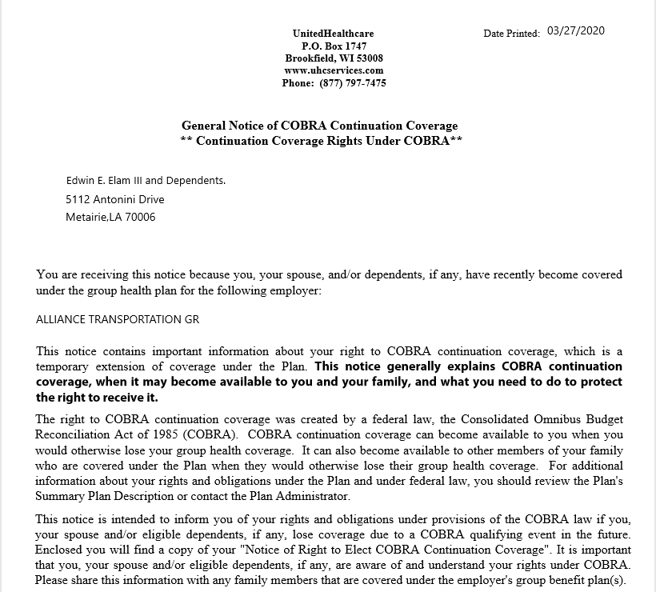

COBRA: Qualifying Event Notification

1. Login to UnitedHealthcare

* Log into the COBRA website at: <https://www.uhcservices.com>
* Hit “Go”

2. Qualifying Event Notification

* Select “Billing Services” from the top navigator.
* Click on “QEN” on the left side of the screen.

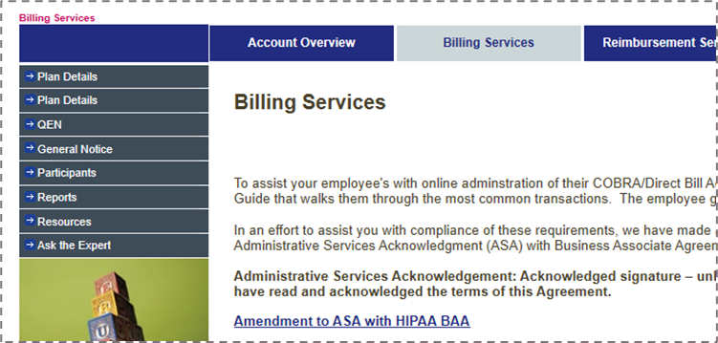

3. Verify SSN:

* Enter Employee’s SSN, including dashes (xxx-xx-xxxx)
* Click “Next Step”.

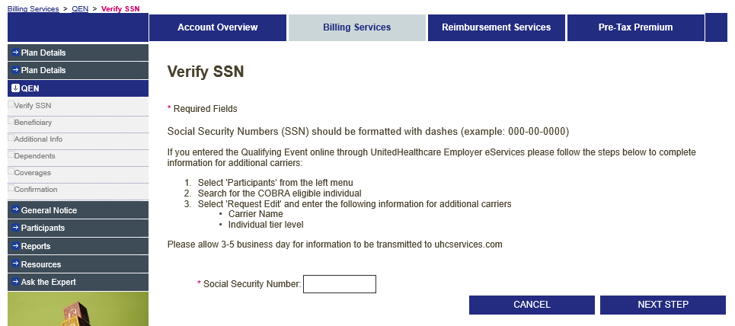

4. Enter Qualifying Event Information

* Enter Info, then click “Next Step”
* The Qualifying Event Date is the date the employee loses eligibility for coverage (ie: last day of employment).

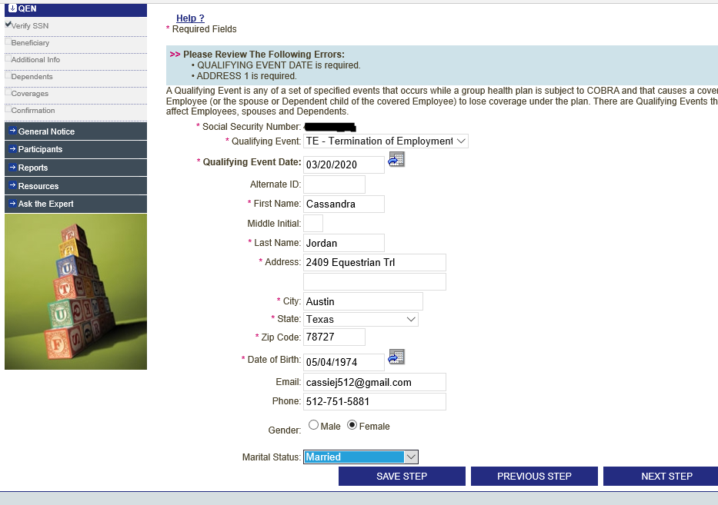

5. Enter Additional Information.

* Only necessary to input Hire Date, then click “Next Step”

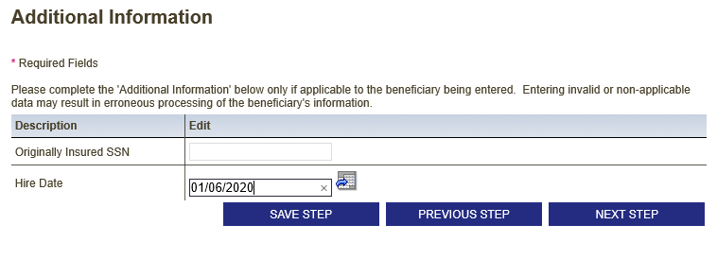

6. Enter Dependent Info

*For this step, use their most recent enrollment forms to gather dependent information.

* Click “Add New” for each dependent, including spouse and children.
* Click “Next Step” when all dependent information is correctly entered.
* If no dependents, proceed by clicking “Next Step.”

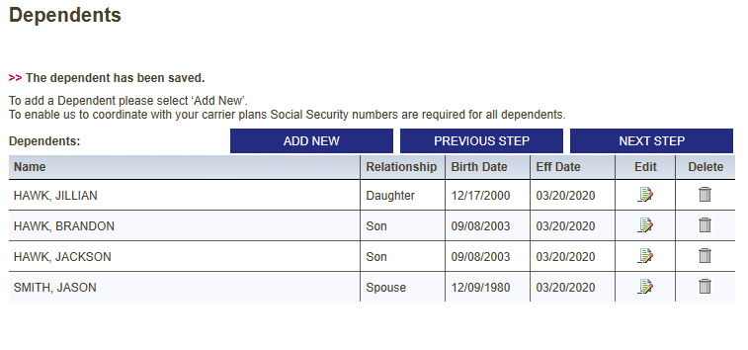

7. Select Coverage Info

For this step, refer to their most recent enrollment forms to gather dependent information.

* Select correct plan and matching tier description for Health, Dental, and Vision.
* Click “Next Step” when completed.

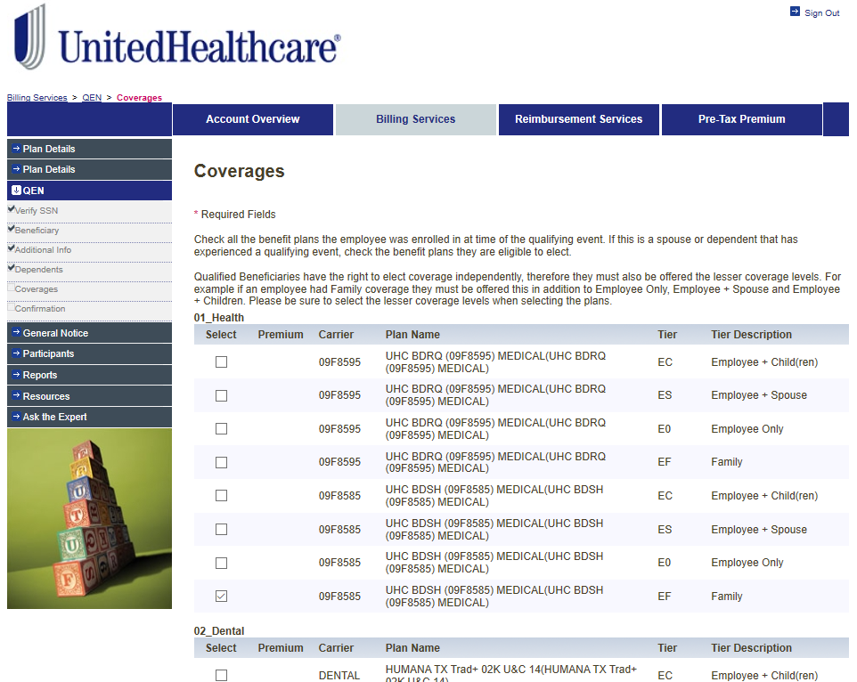

6. Confirmation

* Review accuracy for Health, Dental, and Vision plans selected.
* Click “Submit”
* “Print Report” and save to benefit folder in their personnel file. ( ie: Jordan_C COBRA QEN.pdf )

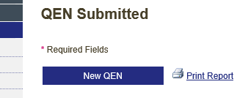

**Resources:**

* A copy of both the General Notice form and The Qualifying Event notice form are saved to the employee’s personnel file in their benefits folder.

**Definitions:**

* COBRA: Consolidated Omnibus Budget Reconciliation Act. COBRA coverage depends on the type of qualifying event - 18 months up to 36 months.
* DOH: Date of Hire
* QEN: Qualifying event Notification